Dominic LaRoche

Lab 7 574G

Assignment 1.

Figure 1 shows the negative outliers of AL99PC, these appear to be located generally on the east and on the border of the map. Figure 2 gives the lower outliers of TURN99PC, these are generally located in the same area as the lower outliers for AL99PC. The outliers for both measures appear to be spatially correlated.

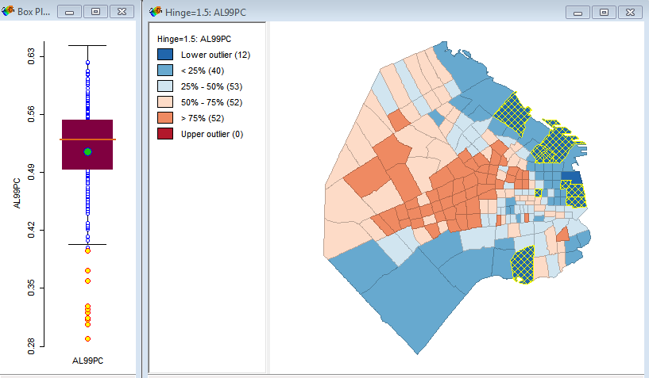

Figure 1. Box plot and box map showing lower outliers of AL99PC.

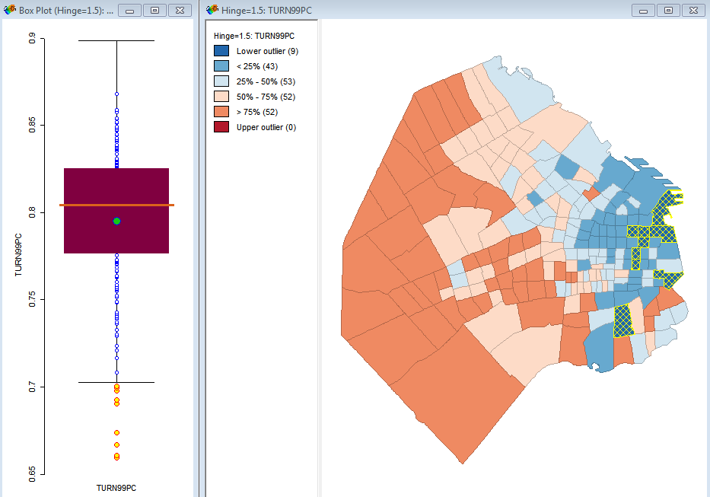

Figure 2. Lower outliers for TURN99PC.

Assignment 2.

Figures 3 and 4 give the conditional plots (conditional on the North and East variables) of AL99PC and TURN99PC respectively. The patterns are generally the same as above with the highest values of AL99PC occurring in the center and west of the region and the lowest values occurring in the south and east. TURN99PC has the highest values in the west and the lowest values in the east without much north to south pattern.

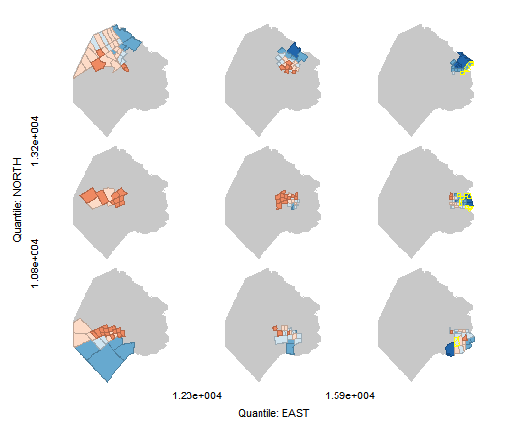

Figure 3. Conditional plot of AL99PC

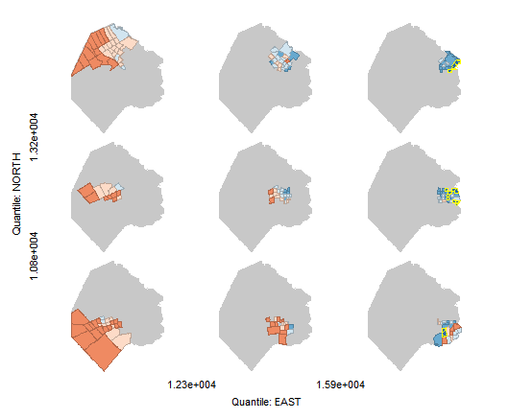

Figure 4. Conditional plot of TURN99PC.

Assignment 3.

Figure 5 gives a boxplot and quantile map of the INC variable from the crime data. The most extreme positive value is just outside the upper whisker of the box plot. However, it does not appear to be an outlier because it does not appear to have undue leverage on the regression line, i.e. the regression line does not change when this point is excluded.

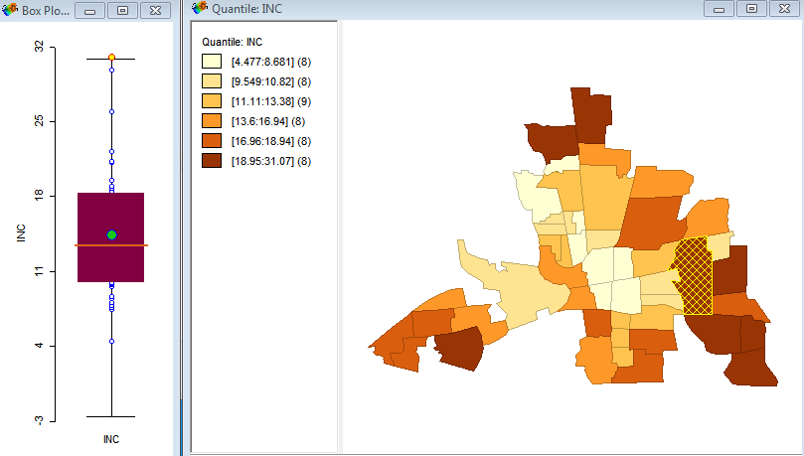

Figure 5. Box-plot and box-map of the INC variable with the upper-most value selected.